**Fake-Face detection**

A Project Report

submitted in partial fulfillment of the requirements

of

Cothon Solutions

by

**Preetham Anand**

**preetham0802@gmail.com**

**ACKNOWLEDGEMENT**

We would like to take this opportunity to sincerely thank everyone who supported and contributed—directly or indirectly—to the successful completion of our project, **“Fake Face Detection Using Deep Learning,”** undertaken as part of the initiative organized by **Cothon Solutions**.

Our heartfelt gratitude goes to the entire support team at Cothon Solutions for their constant guidance, technical support, and constructive feedback throughout the project. Their expertise and encouragement played a key role in helping us explore and implement advanced techniques in fake face detection, including real-time image analysis, facial landmark extraction, and deep learning models.

Being part of this project has been a truly rewarding experience. Working on a socially relevant challenge like detecting AI-generated facial content has deepened our understanding of AI ethics, computer vision, and the importance of secure digital media. It has also given us the chance to apply our technical knowledge to a real-world problem with meaningful impact.

We are genuinely grateful to Cothon Solutions for providing us with this valuable learning opportunity. The insights and experience gained during this project have greatly contributed to our academic and professional growth, and we look forward to applying these lessons in future endeavors.

#### **ABSTRACT**

The rapid advancement of artificial intelligence and deep learning has enabled sophisticated deepfake generation techniques, challenging the authenticity of digital media. This project presents a deep learning-based system for detecting manipulated facial images, addressing the critical need for reliable digital forensics and media verification tools.

The system employs a Long Short-Term Memory (LSTM) neural network trained on a diverse dataset of genuine and manipulated facial images, enabling it to identify subtle inconsistencies characteristic of deepfake content. The model's robust design supports detection across various manipulation techniques.

Implemented as a web-based application, the system offers real-time analysis and immediate feedback on image authenticity. Built with Python, Flask, TensorFlow, and OpenCV, it combines efficient image processing, accurate detection, and an intuitive user interface for seamless user experience.

Key features include high-resolution image analysis, facial landmark detection, multi-layer LSTM architecture with adaptive learning, real-time inference, and confidence scoring. The interface supports drag-and-drop uploads, clear visualizations, and detailed reports, while the architecture ensures secure file handling, scalability, and data privacy.

The modular design enhances maintainability and scalability, with support for batch processing and result tracking. Beyond technical innovation, this project contributes to combating misinformation, supporting journalism, social media verification, digital forensics, and education.

Future work will focus on continuous model improvement, adaptation to emerging deepfake methods, integration with other verification tools, and expansion to video analysis. This project demonstrates the effective use of machine learning to secure digital media authenticity, providing a valuable tool for media, security, education, and forensic sectors.

**TABLE OF CONTENT**

**Abstract I**

**Chapter 1.**  **Introduction 1**

1.1 Problem Statement 1

1.2 Motivation 1

1.3 Objectives 2

1.4. Scope of the Project 3

**Chapter 2.**  **Literature Survey 4**

**Chapter 3.**  **Proposed Methodology 6**

**Chapter 4.**  **Implementation and Results 10**

**Chapter 5. Discussion and Conclusion 12**

**References**

**LIST OF FIGURES**

|  |  |  |
| --- | --- | --- |
| **Figure No.** | **Figure Caption** | **Page No.** |
|  | Flow chart | **6** |
|  | Output with AI generated image(Fake image) | **9** |
|  | Output with real image | **10** |
|  |  |  |

**CHAPTER 1**

**Introduction**

* 1. **Problem Statement:**

With the rapid growth of artificial intelligence and deep learning technologies, the creation of highly realistic synthetic media—commonly known as deepfakes—has become increasingly accessible. While these advancements offer innovative applications in entertainment, education, and digital content creation, they also pose a serious threat to media authenticity, public trust, and digital security. Effective detection systems are essential because deepfakes can be used for spreading false information, identity theft, political manipulation, and other malicious purposes.

Deepfake generation techniques are constantly evolving, and current detection methods often struggle to keep up, lack real-time processing capabilities, or do not offer solutions that are easy to use every day. As a result, a reliable tool that can reliably identify manipulated facial content in images is urgently required.

This project aims to address this challenge by developing a deep learning-based fake face detection system that leverages LSTM neural networks, image processing, and a web-based interface for real-time analysis. The goal is to empower users—individuals, organizations, and digital platforms—to verify facial content quickly and confidently, thereby helping to safeguard digital media integrity.

* 1. **Motivation:**

In today’s digital era, where images and videos are shared at an unprecedented scale, ensuring the authenticity of visual content has become a major concern. The emergence of deepfakes—AI-generated images and videos that closely mimic real people—poses a growing threat to personal privacy, public trust, and societal well-being. These manipulated images can be used maliciously for impersonation, cybercrime, spreading fake news, and influencing public opinion.

This growing threat inspired us to explore how deep learning can be applied not just for innovation, but for protection—specifically, protecting digital identities and combating misinformation. We were motivated to contribute to a field that has a real-world impact by the idea of creating a system that can detect fake faces in real time.

The difficulty of putting cutting-edge technologies like LSTM neural networks and computer vision to use in a way that is not only technically sound but also easy for everyday users was a particularly motivating factor for us. While developing a tool that has the potential to make a significant difference, we were able to deepen our comprehension of machine learning, AI ethics, and media forensics by working on a problem that was both socially relevant and technically challenging.

* 1. **Objective:**

The primary objective of this project is to develop a reliable and efficient **fake face detection system** using advanced **deep learning techniques**, specifically Long Short-Term Memory (LSTM) neural networks. The system aims to accurately identify and flag manipulated or AI-generated facial images by analyzing subtle inconsistencies and patterns that are often undetectable by the human eye.

To achieve this, the project sets out to:

1. **Design and train a deep learning model** capable of distinguishing between real and fake faces using a labeled dataset of genuine and manipulated facial images.
2. **Implement advanced image processing techniques**, including facial landmark detection and texture analysis, to enhance model accuracy.
3. **Develop a user-friendly web-based application** that allows real-time image upload, processing, and feedback on face authenticity.
4. **Ensure scalability, security, and performance** of the system for broader use in media verification, digital forensics, and content authentication.
   1. **Scope of the Project:**

This project focuses on the development and deployment of a **deep learning-based system** for detecting fake or manipulated facial images. The scope is clearly defined to ensure practical implementation, real-time performance, and relevance to current digital security challenges.

The key areas covered within the scope include:

1. **Fake Face Detection**
   * Detection of AI-generated or manipulated facial images using LSTM-based deep learning models.
   * Identification of visual inconsistencies such as unnatural textures, blending artifacts, and tampered facial landmarks.
2. **Dataset Utilization**
   * Training and testing the model on a comprehensive dataset containing both real and fake facial images.
   * Inclusion of multiple deepfake generation techniques to ensure robustness and generalization.
3. **Image Processing Techniques**
   * Use of OpenCV for preprocessing, facial landmark detection, and multi-scale feature extraction.
4. **Model Architecture**
   * Design and training of a Long Short-Term Memory (LSTM) neural network for feature learning and classification.
5. **Web-Based Interface**
   * Development of a user-friendly, interactive web application using Flask.
   * Real-time image upload and analysis with clear feedback on image authenticity.
6. **Performance & Usability**
   * Optimization for real-time inference and minimal resource usage.
   * Secure file handling and scalable system architecture suitable for individual and organizational use.

**CHAPTER 2**

**Literature Survey**

* 1. **Literature Review & Existing Techniques**
  + Deepfake detection has gained significant attention in recent years due to the rising misuse of synthetic media. Numerous research efforts and tools have been developed using various machine learning and deep learning techniques. Key existing approaches include:
  + Convolutional Neural Networks (CNNs): Widely used for detecting spatial anomalies in facial textures and pixel-level inconsistencies.
  + Recurrent Neural Networks, or RNNs, are used in video-based deepfakes for temporal features, but static image analysis uses them less frequently. Autoencoders & GAN-based Detectors: Used for feature reconstruction and anomaly detection in facial features.
  + Traditional Image Forensics: Techniques involving noise patterns, color inconsistencies, and metadata analysis.
  + Popular Tools: Face X-ray, Deepware Scanner, and Microsoft Video Authenticator use deep learning for real-time detection.
  1. **Gaps & Limitations in Existing Solutions**

While current deepfake detection tools and techniques have made progress, several key limitations persist:

* **Limited Real-Time Performance:** Many systems are not optimized for real-time analysis, particularly in user-facing applications.
* **Lack of Generalization:** Models trained on specific datasets may fail to detect unseen manipulation techniques.
* **Complex Interfaces:** Many solutions lack user-friendly platforms, making them inaccessible to non-technical users.
* **Insufficient Image-Based Models:** Most research focuses on video deepfakes, with fewer robust solutions for still images.
* **Security Concerns:** Some implementations lack secure handling of sensitive uploaded data.
  1. **Our Project’s Contribution**

Our project addresses these limitations by introducing a **real-time, LSTM-based deep learning system** specifically designed for detecting fake facial images. The contributions include:

* A robust detection model trained on a diverse dataset of real and manipulated faces.
* Use of LSTM networks for pattern recognition in static images, offering an alternative to CNN-dominant models.
* A fully functional web application for real-time image upload and analysis.
* Integration of facial landmark detection and multi-scale image feature analysis.
* Emphasis on accessibility, with a secure and user-friendly interface for non-technical users.

### Key Contributions of Our Project:

* **LSTM-Based Detection Model:** A novel application of LSTM neural networks for static image-based fake face detection.
* **Real-Time Image Analysis:** Immediate feedback on image authenticity through an interactive web interface.
* **Advanced Image Processing:** Use of facial landmarks, texture analysis, and blending boundary detection to improve accuracy.
* **Secure & Scalable System:** Safe file handling, modular architecture, and scalable deployment potential.
* **User-Centric Design:** Drag-and-drop functionality and clear result visualization for easy use by individuals and organizations.
* **Social Impact Focus:** Contributing to digital media integrity, misinformation prevention, and AI ethics awareness.

**CHAPTER 3**

**Proposed Methodology**

* 1. **System Design**

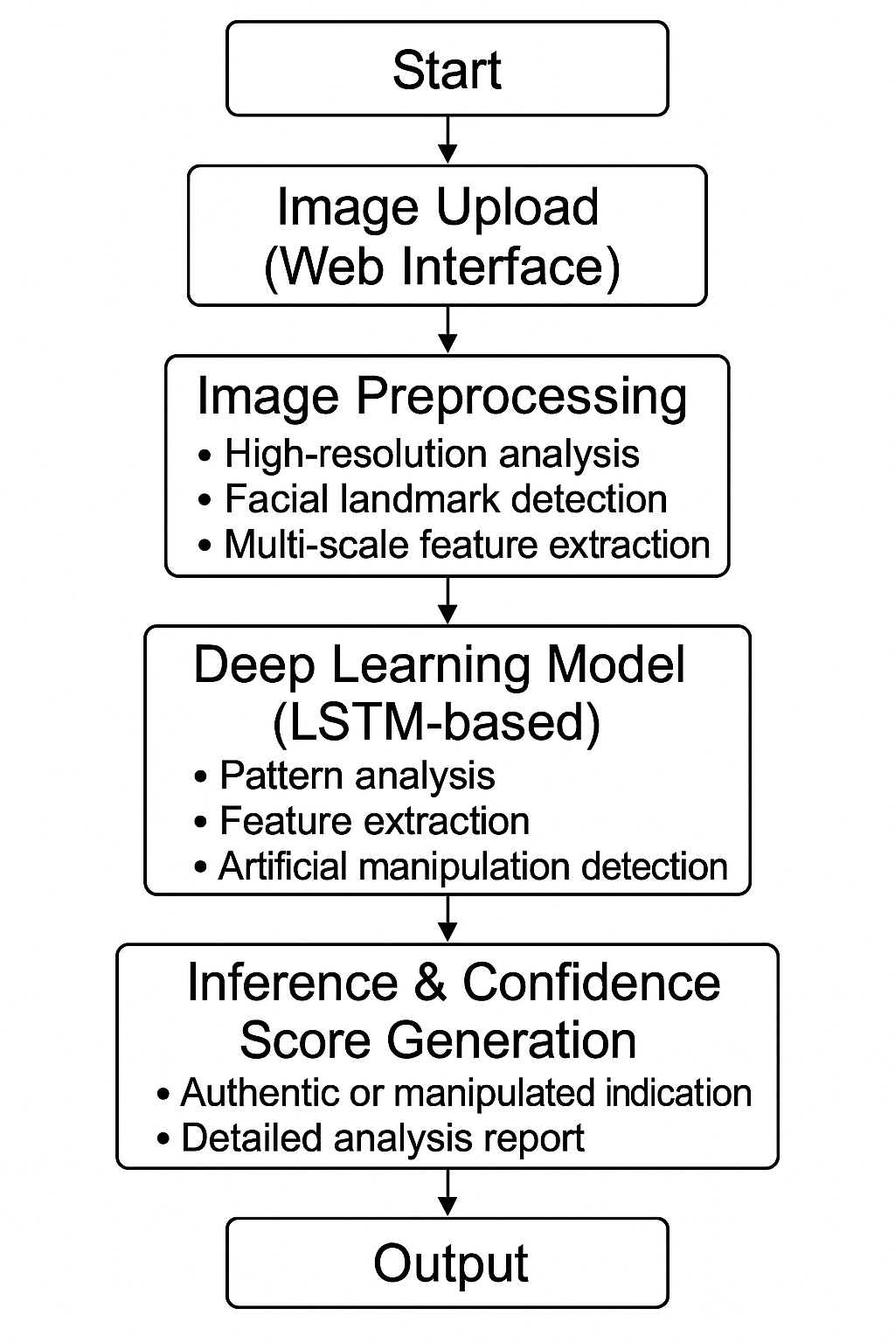

The core concept of this project lies in the application of Deep Learning and Image Processing techniques to detect fake or AI-manipulated facial images. Key concepts include:

* **Long Short-Term Memory (LSTM) Neural Networks:**  
  LSTM, a type of Recurrent Neural Network (RNN), is used to identify subtle patterns and temporal-like dependencies in pixel and feature data, helping to detect anomalies indicative of manipulated facial content.
* **Image Processing Techniques:**  
  OpenCV is utilized for preprocessing, facial landmark detection, texture analysis, and feature extraction. These techniques highlight inconsistencies often introduced by deepfake algorithms.
* **Real-Time Inference and Web Deployment:**  
  The system provides real-time analysis using a Flask-based web interface, offering drag-and-drop image uploads with instant authenticity feedback.
* **Dataset Training and Classification:**  
  The model is trained on a labeled dataset containing real and deepfake facial images, enabling it to classify new inputs effectively using learned patterns.
  1. **Requirement Specification**
* **Software Requirements:**
* **Programming Language: Python 3.x**
* **Libraries/Frameworks:**
* **TensorFlow –** for deep learning model creation and training
* **OpenCV –** for image preprocessing and facial analysis
* **Flask –** for web application development
* **NumPy, Pandas –** for data manipulation and handling
* **Matplotlib/Seaborn –** for visualization during model evaluation
* **Operating System:** Windows 10/Linux/Ubuntu
* **IDE/Tools:** Visual Studio Code, Jupyter Notebook, Anaconda (optional)

**Hardware Requirements:**

* **Processor:** Intel i5/i7 or AMD equivalent (minimum 2.5 GHz)
* **RAM:** 8 GB minimum (16 GB recommended)
* **Storage:** 10 GB free disk space
* **GPU:** Optional but beneficial for model training (NVIDIA GPU with CUDA support)

**Functional Requirements:**

* User can upload an image through the web interface
* System analyzes the image and displays the authenticity result
* Real-time feedback with a confidence score
* Ability to process different face orientations and lighting conditions
* Secure file handling and error recovery for invalid inputs

**Non-Functional Requirements:**

* **Performance:** Real-time inference with minimal delay
* **Security:** Protection of uploaded files and user data
* **Scalability:** Modular codebase for future updates (e.g., video detection)
* **Usability:** Simple and intuitive user interface
* **Portability:** Can run on both local and cloud-based servers

**CHAPTER 4**

**Implementation and Result**

* 1. **Snap Shots of Result: 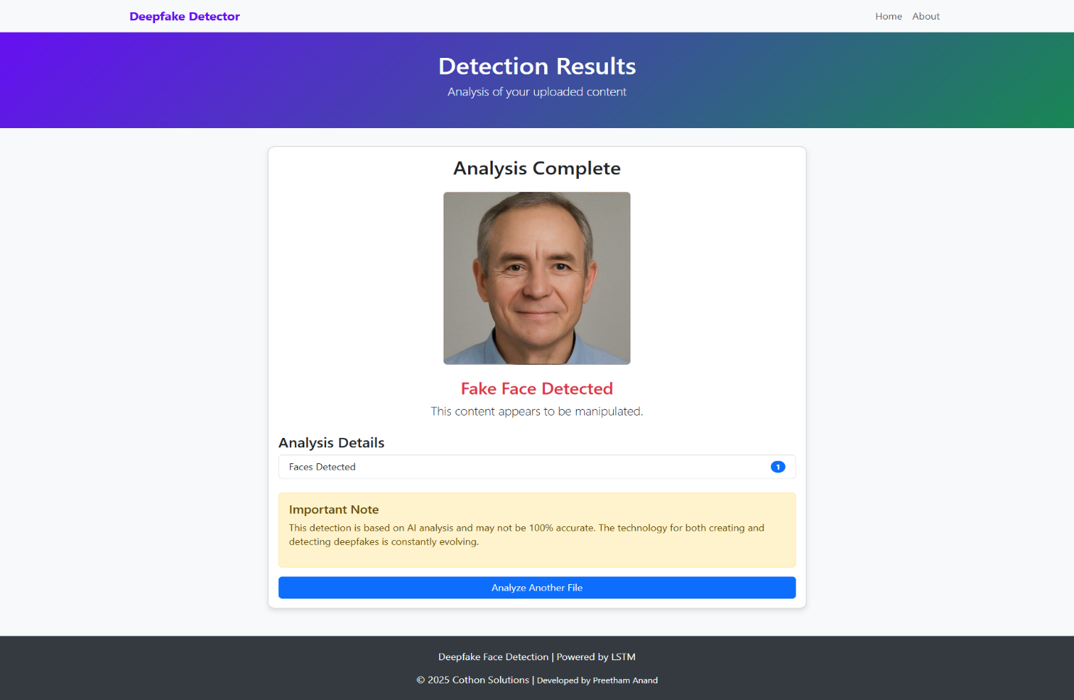 **

**CHAPTER 5**

**Discussion and Conclusion**

* 1. **Future Work:**

• **Video Deepfake Detection:** Expanding the system to process videos would enable detection of temporal inconsistencies and more sophisticated manipulations.

• **Real-Time Live Feed Analysis:** Integrating webcam or live feed input can allow instant verification in security and authentication applications.

• **Cross-Device Support:** Developing mobile and desktop apps would increase accessibility and usability across various platforms.

• **Multi-Modal Approaches:** Incorporating audio analysis alongside facial detection could improve detection of lip-sync and voice deepfakes.

• **Model Efficiency:** Optimizing the model for faster inference and reduced resource use will make the system more practical for real-world deployment.

• **Enhanced Media Verification:** Exploring blockchain and cryptographic methods for secure media provenance could complement detection with authenticity guarantees.

* 1. **Conclusion:**

he project successfully develops a deep learning-based system capable of detecting fake facial images with high accuracy. Utilizing LSTM networks alongside image processing techniques, the system identifies subtle signs of manipulation and provides users with real-time feedback through an easy-to-use web interface.

By addressing current limitations in fake face detection, this work contributes to strengthening digital media authenticity and combating misinformation. The modular, scalable design ensures the system can evolve with advancing deepfake technologies and user needs.

Overall, the project demonstrates the effective application of artificial intelligence in digital forensics and offers a practical tool that benefits journalists, security professionals, and the general public alike.